- CPU high alarm
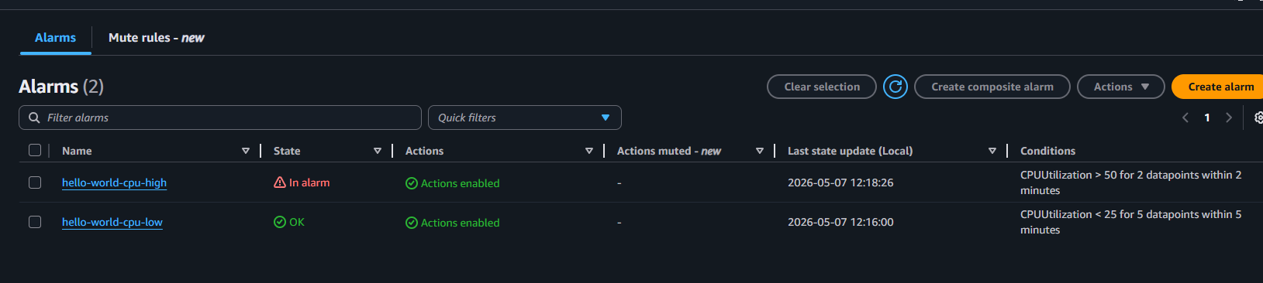
- Scale out
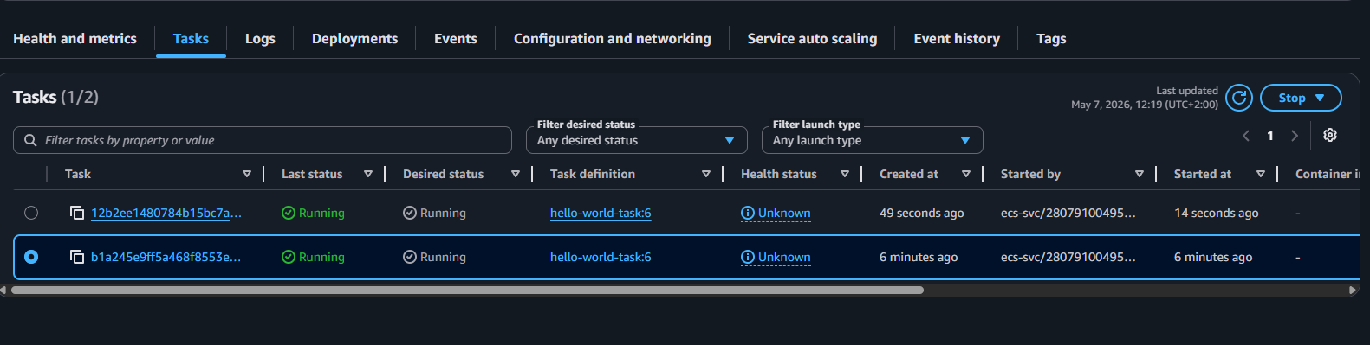
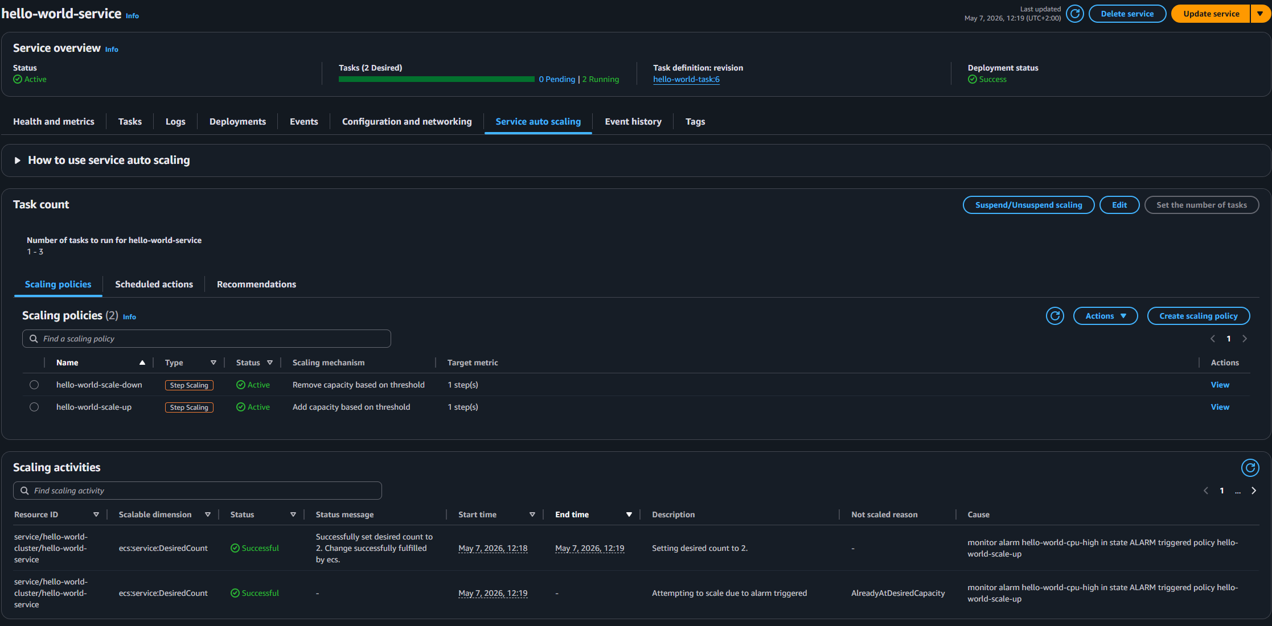

- Scale in
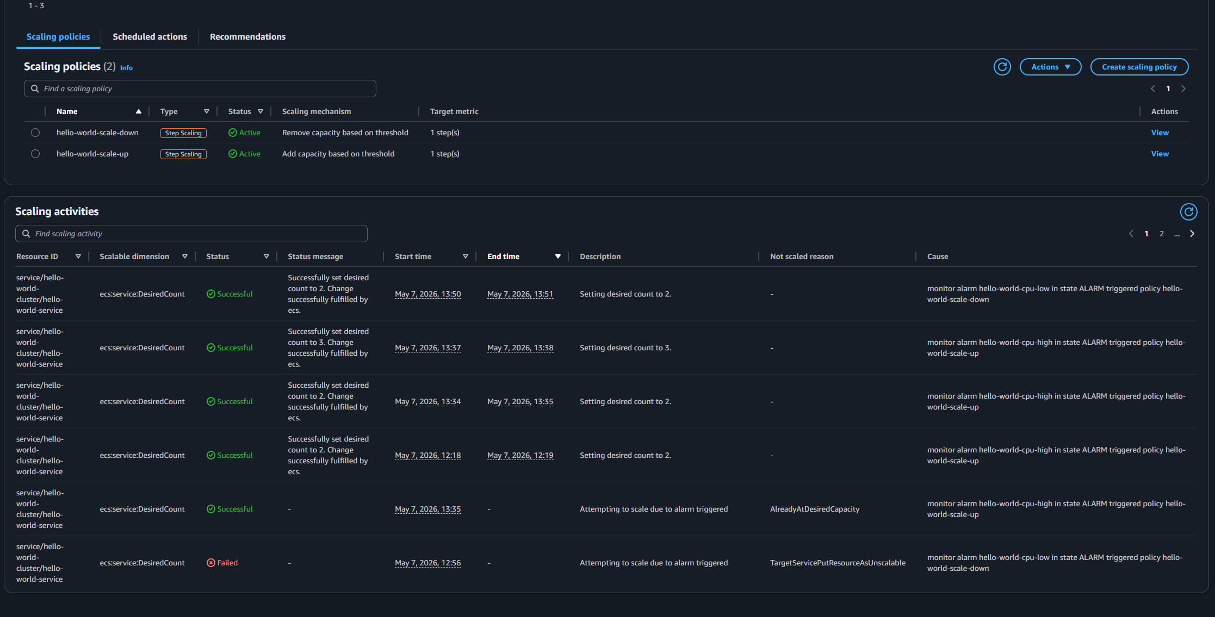
I had to destroy infrastructure and apply it again because i configured scaling in wrong. There were some issues with it so that is why there is an hour gap.

